
CONFIDENTIAL CS/NOV 2026/ICT450

UNIVERSITI TEKNOLOGI MARA FINAL EXAMINATION

COURSE
COURSE CODE
EXAMINATION TIME
DATABASE DESIGN AND DEVELOPMENT

ICT450
NOVEMBER 2026
3 HOURS

INSTRUCTIONS TO CANDIDATES

- This question paper consists of five (5) questions.

- Answer ALL questions in the Answer Booklet. Start each answer on a new page.

- Do not bring any material into the examination room unless permission is given by the invigilator .
- Please check to make sure that this examination pack consists of: i) the Question Paper
  - an Answer Booklet - provided by the Faculty

- Answer ALL questions in English.

DO NOT TURN THIS PAGE UNTIL YOU ARE TOLD TO DO SO

This examination paper consists of 6 printed pages.

QUESTION 1 (20 marks)
a) Organizations use data to keep track of their day-to-day operations. Such data is likely to be managed most efficiently when it is stored in a database. Explain the meaning of data and database.
(4 marks)
b) The Database Management System (DBMS) serves as the intermediary between the user and the database. One of the advantages of DBMS is minimized data inconsistency. Briefly explain data inconsistency and illustrate ONE (1) example.
(4 marks)
c) Zinnirah has been appointed as a junior database developer in ZY Stationary company. She is tasked to create a database system to keep track of its customers, orders, and products. Zinnirah has created a database that consists of three tables which are Customers, Orders, and Products. However, the relational operations become very complex and are likely to lead to system efficiency errors and output errors. State the problem that Zinnirah is facing and illustrate the solution (an ERD) to overcome the problem.
(6 marks)
d) Maintenance is one of the important phases in Systems Development Life Cycle (SDLC). Briefly explain THREE (3) types of maintenance in SDLC.
(6 marks)
QUESTION 2 (20 marks)
a) Database Life Cycle (DBLC) is a properly designed framework for implementing a database system. The proper database design leads to an efficient data retrieval. Briefly explain FOUR (4) activities in the database design phase.
(8 marks)
b) XYZ Technologies Sdn. Bhd. is planning to implement a mobile database for their company due to increasing branches in Malaysia and Indonesia. Do you think that mobile database is suitable for this company? Briefly describe THERE (3) factors that contribute to the wide usage of mobile database.
(8 marks)
c) Data is a raw and unorganized fact that required to be processed to make it meaningful. State the differences between structured and unstructured data.
(4 marks)
QUESTION 3 (20 marks)
Figure 1 shows a Sales Invoice for a new start-up company, Sasa eStore. This invoice is manually generated from Microsoft Excel.
Based on the information given, answer the following questions:
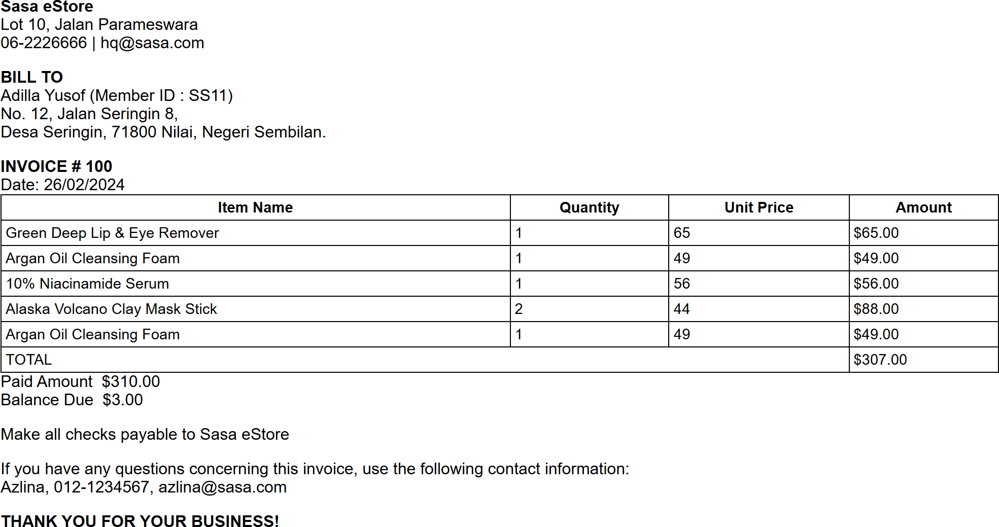
Figure 1: Sasa eStore Sales Invoice
a) State the normal form of the Figure 1. Explain your answer with reasons.
(3 marks)
b) Identify the primary key(s) and partial dependencies and/or transitive dependencies.
(6 marks)
c) Normalize this invoice form from the First Normal Form (1NF) until the Third Normal Form (3NF). List all the steps involved.
(11 marks)
QUESTION 4 (20 marks)
The relational schema below shows the e-Travel Package database system for one of the local travel agents in Malaysia.
CUSTOMERS (CustomerID, FirstName, LastName, PhoneNumber)
BOOKING (BookingID, BookingDate, NumberOfPax, TripDate, CustomerID*, GuideID*, PackageID*)
GUIDE (GuideID, GuideName, BasicSalary, HireDate)
PACKAGE (PackageID, PackageName, PricePerPax, PackageDetails)
Write the SQL statements based on the following requirements:
a) Calculate the total number of trips for each date.
(4 marks)
b) Display the details of customer who make a highest number of booking.
(4 marks)
c) Increase 10% of the salary for all guides who works on a trip in February 2025.
(4 marks)
d) Display the full name of packages that has been booked more than 70 times.
(4 marks)
e) Identify the total number of customers that make a booking in Feb 2025 until March 2025.
(4 marks)
QUESTION 5 (20 marks)
Clean Environment Sdn. Bhd is a new company located in Jasin, Malacca. This company is planning to develop a solid waste recycling database system for better coordination and reporting on the monitoring, collection, and disposal of waste from each locality. As a database designer, you are tasked to design the database system according to the following requirements:
- Record the details of the collector, such as their collector ID, name, and phone number.
- Among the collectors, several are supervisors. Each collector is managed by one supervisor, and each supervisor manages many collectors.
- Each collector is assigned to several collection duties. Each duty involves only one collector. The date for the collection is recorded in the system.
- Each collection duty session is for one locality and uses one vehicle.
- Locality details, such as locality ID, locality name, and postcode, are recorded in the system.
- Vehicle details, such as the plate number, model, and size, are recorded in the system.
- Each locality contains several houses, and each house is located in one locality. The address and category of each house are recorded in the system.
- Each collection duty session collects various types of solid waste.
- Each piece of solid waste has an ID, name, and category.
- The total weight of the collected solid waste is also recorded in the system.
Based on the given information:
a) Construct a complete Entity Relationship Diagram (ERD) with all of the required tables, attributes, and relationships using the Crow's Foot notation that reflects all of the given business rules.
(16 marks)
b) Identify TWO (2) relevant information that you can get from the ERD you constructed in (a).
(4 marks)

